Smart Cattle Monitoring System with IoT and AI/ML

**Project Proposal**



**Internal Supervisor**

Sir Iqbal Uddin Khan

**Submitted by**

Zunair Shahid

2422-2021

Hina Roshan

1389-2019

**Department of Computer Science,**

Hamdard University, Karachi.

2th of October 2024

# **Introduction:**

Livestock farming plays a vital role in the agricultural and economic sector of Pakistan. However, the livestock farmer uses their old and traditional methods of monitoring cattle health and fertility detection. The “**Smart Cattle Monitoring system by using IOT and AI/ML**” is a product which helps the livestock farmers to effectively monitor their cattle health, detect diseases, injuries, track activities, movements and location of the cattle. Utilizing Internet of Things (IoT) and Artificial Intelligence (AI), this system enhances cattle management and farm productivity.

# **Objective:**

The Objective of the Smart cattle monitoring system using IoT sensors to collect and AI is to analyze, and provide understanding into cattle health, activities, ultimately improving farm management decisions and farm productivity.

# **Problem Description:**

Livestock plays an important role in the uplift of the rural economy. It's share in the National GDP is 14.36% and it contributes 62.68% to Agricultural GDP. [1]

However, traditional livestock cattle monitoring is still based on visual observation or manual recordings, which raises inaccuracies in health monitoring. The methods in traditional cattle monitoring are labor intensive and time-consuming but frequently inaccurate. The lack of real-time monitoring and analysis of data can lead to delays in detecting diseases or injuries in cattle, which can potentially result in death. This also reduces productivity.

**What is the main motivation for choosing this problem?**

As of 2020, there were approximately 41.2 million buffaloes, 49.6 million cattle, 5.4 million donkeys, 78.2 million goats and 30.9 million [sheep](https://en.wikipedia.org/wiki/Sheep) in Pakistan[2]

So it's one of the largest sectors which plays an important role in the Pakistan economy. The motivation for choosing smart cattle monitoring systems in Pakistan is to propel the livestock sector towards becoming one of the top 5 largest producers globally.

**What is the main use of AI and IoT in Smart Cattle monitoring system?**

**IoT (Internet of Things):**

**Data Collection:**

* **Sensors:** IoT devices such as temperature sensors, heart rate monitors, and accelerometers are attached to the cattle to continuously collect data.
* **GPS Modules:** GPS modules track the location and movement of cattle in real-time.
* **Microcontrollers:** Devices like Raspberry Pi process and transmit the collected data to cloud storage.

**Data Transmission:**

* **Connectivity:** The collected data is transmitted wirelessly via Wi-Fi communication protocol to a central cloud-based system for further analysis.

**Real-Time Monitoring:**

* **Continuous Monitoring:** IoT enables continuous and real-time monitoring of cattle health and behavior, ensuring immediate detection of any anomalies.

**AI (Artificial Intelligence)**

**Data Analysis:**

* **Health Monitoring:** AI algorithm analyze the health data collected by IoT sensors to detect anomalies and monitor overall health trends.

**What will be the benefits for a farmer/livestock owner to use this smart cattle monitoring system?**

* It will provide early detection of health issues such as low heart rate or injuries that can prevent unusual death.
* It will do cost reduction as farmer take action before health issue escalates
* Farmers can remotely monitor through App about the cattle.
* A farmer can make a long term plan for the cattle's health and for risk management.

**What will be the features for a farmer/livestock owner to use this smart cattle monitoring system?**

* It will provide the overall health monitoring of the cattle like body temperature, heart rate, activities, movements, locations.
* They will easily see the status of the cattle or farm on Mobile App which will be a bilingual app English and Urdu, so they will easily understand the status.

**Why should a farmer/livestock owner use this smart cattle monitoring system?**

* It will help the farmers to reduce their cost on the cattle monitoring or health.
* They can easily monitor their cattle from anywhere in the world.

# **Literature Review**

|  |  |  |  |  |
| --- | --- | --- | --- | --- |
| **Literature Review-Summary** | | | | |
| **Paper Title** | **Publication Year** | **Source** | **Gap** | **Reference** |
| Smart IOT  Cloud Based Livestock Monitoring System | 2021 | Google Scholar | This paper proposed working on a IOT  Cloud Based model with different sensors to generate data and send data to cloud and shows the data on the dashboard or app [3]. The proposed paper is working in such a manner that alongside other factors aimed to provide ease to farmers we are also working on the integration of AI in it so it will scan the data, analyze it and then suggest an action according to the data which will be a plus point to farmer so it can easily understand the problems in cattle. | [3] |
| Cattle Health and Environment Monitoring System | 2017 | Google Scholar | The proposed paper focuses on leveraging IoT (Internet of Things) technology to monitor the health and environmental conditions affecting cattle with a UI like mobile application or web application with carts and diagrams for the help of farmers [4]. I’m also working with the same approach but I’m adding a new feature which is a dual language app with English and Urdu in it so that farmers can easily understand the status. | [4] |
| A Study On IoT And Ai-Based Advanced Architecture For Livestock Management. | 2021 | Google Scholar | This article presents an IoT and AI-based advanced architecture for livestock management. The system uses IoT devices to gather biomedical sensing data and images of animals, which are then sent to an AI cloud database to establish a standard for animal wellbeing and behavior. The system uses AI to analyze the data in real-time and alert animal managers in case of any abnormalities. The article also discusses the development of an intelligent animal care and management architecture that uses IoT, AI, cloud databases, and distributed computing to help zookeepers manage animals more effectively. [5] This paper was studied to understand the role of the AI so that implementation can be done with better accuracy and features in the proposed project. | [5] |
| A design of a smart farm system for cattle monitoring | 2023 | Research gate | The study explores IoT and AI-based smart cattle health monitoring systems. The paper details the integration of IoT devices like skin temperature sensors, heart rate monitors, and motion sensors to monitor vital parameters in cattle. Data collected from these sensors is processed using machine learning algorithms to predict health status, facilitating early disease detection and timely intervention.[6] The study is focused on general health monitoring, I’m focusing on general health monitoring. | [6] |
| IOT and AI based smart cattle health monitoring | 2023 | Google Scholar | The study by Darvesh et al. (2023) presents an innovative IoT and AI-based system for smart cattle health monitoring, addressing the critical need for effective health management in large-scale dairy farming. With the increasing demand for dairy products, the system leverages various IoT devices—such as skin temperature, heart rate, and motion sensors—to continuously monitor key health indicators like heart rate, activity levels, and heat stress. The integration of machine learning algorithms with cloud technology enables real-time data analysis and health status predictions, which are displayed on a user-friendly mobile app. This approach not only enhances the welfare of cattle by facilitating early disease detection and treatment but also optimizes farm management by reducing labor-intensive monitoring tasks, making it a cost-effective solution for improving livestock health and productivity. [7] I have studied this to gain a better understanding of the cloud storage used in the monitoring system, ensuring more accurate implementation in the proposed project. | [7] |
| IoT sensors for smart livestock management | 2019 | Science direct | This article provides a comprehensive survey on the role of IoT in the livestock field. It discusses the IoT network infrastructure, topologies, and platforms employed for livestock management, as well as communication protocols and connections with relevant technologies. The article also explores various IoT-based livestock monitoring, controlling, and tracking applications. Additionally, it analyzes distinct security issues in the IoT-based livestock field and proposes a collaborative security model to detect and minimize the security risk. [8] I have studied this to better understand the security part of system so that implementation can be done with better accuracy in the proposed project. | [8] |
| An enhanced pursuit of sustainable remote livestock tracking and geo fencing using IoT and GPRS | 2020 | Wiley | The article discusses a smart solution for livestock tracking and geo fencing using IoT technology. The system creates a geographical safe zone for cattle, assigning dedicated IoT sensors to them, enabling remote monitoring and control without the need for physical intervention by farmers. The smart system collects data regarding the location, well-being, and health of the livestock, which can help prevent the spread of COVID-19, lower farming costs, and enable remote monitoring. [9] I have studied it to get the understanding  of the hardware sensor part | [9] |
| An IoT based multi-sensory intelligent device for cattle activity monitoring. | 2022 | [science direc](https://www.sciencedirect.com/science/article/abs/pii/B9780128154090000152)t | The devices is an IoT-based multi-sensory intelligent device designed for cattle activity monitoring, which can detect anomalies in activities that may indicate health or welfare issues. The device consists of a temperature sensor, 3-axis accelerometer, and GPS module, transmitting data to a remote server for analysis using machine learning algorithms. In experiments, the Monitor achieved an overall classification accuracy of 97% using an XG Boost classifier, outperforming a Random Forest classifier. The device's multi-sensory approach can detect changes in body temperature and walking speed, enabling early detection of diseases such as mastitis and foot-and-mouth disease, and has the potential to improve cattle health and welfare. [10] This paper was studied to understand the role of the sensors like accelerometer, GPS, temperature sensor so that implementation can be done with better accuracy in the proposed project. | [10] |

# **Gap Analysis:**

We have studied the above papers and some research and analysis the gap about the cattle monitoring which are:

1. The UI interface where farmers will see their farm status is in English language which are difficult to understand by the farmers in Pakistan.
2. I've realized that current cattle health monitoring devices are too expensive, making it hard for many farmers to invest in the technology that could help their farms.
3. Many monitoring systems rely on wearable devices with limited battery life, making it inconvenient for farmers to continually replace or recharge them.

# **Methodology:**

**Water Fall Approach:**

The Waterfall approach will be used for the Smart Cattle Monitoring System, as it's ideal for projects with well-defined requirements and outcomes. This linear and sequential methodology ensures a structured development process, where each phase is completed before moving on to the next. The phases include requirements gathering and analysis, system design, implementation, testing, deployment, and maintenance. This approach provides a thorough and systematic development process, reducing the risk of defects and failures. It's suitable for this project, as the requirements are clear and the outcomes are well-understood, allowing for a predictable and controlled development process.

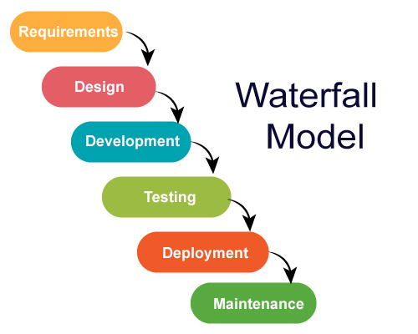

Source (www.medium.com)

**Why Water- Fall Model is accurate for our Project?**

The Waterfall methodology is a great fit for our cattle health monitoring system project because of its clear, structured approach, which aligns perfectly with our well-defined project goals. With specific objectives like integrating AI, developing a mobile app, and utilizing cloud services, Waterfall allows us to plan, develop, and test each phase methodically. This step-by-step process ensures that we can manage timelines and milestones effectively while maintaining clarity throughout. Its emphasis on detailed documentation will also be beneficial for future updates or improvements. By testing after development, we can ensure that all components function smoothly, making Waterfall the ideal choice for delivering a robust and reliable system.

# **Project Scope:**

**In Scope:**

**Design and Development of Hardware Components:** Selection and integration of sensors (body temperature, pulse rate, activity) and GPS modules with microcontrollers (Raspberry Pi).

**Software Development:** Creation of firmware for microcontrollers, development of a cloud-based data storage solution, and implementation of mobile applications for monitoring.

**AI/ML Algorithm Development:** Design and implementation of machine learning algorithm for cattle status prediction.

**System Integration:** Ensuring seamless integration between hardware components, software, and cloud services for effective data transmission and storage.

**User Interface Design:** Development of user-friendly interfaces for farmers to access real-time data and receive alerts with a bilingual app language to understand by the farmer.

**Initial Testing and Validation:** small-scale farm or own limited number of cattle tests to validate the system’s functionality and performance.

**Out of Scope:**

**Extensive Field Testing:** Large-scale field testing and long-term performance evaluation beyond the initial proof-of-concept validation will not be conducted within the project timeline.

**Custom Hardware Development:** Development of custom hardware components beyond commercially available sensors and microcontrollers is not included.

**Post-Deployment Support and Maintenance:** Continuous support, maintenance, and updates after the initial deployment phase will not be covered.

**Scalability and Redundancy Solutions:** Design and implementation of scalability solutions and redundant systems for large-scale deployments are out of the project’s current scope.

**Assumptions:**

**Availability of Internet Connectivity:** It is assumed that the farms where the system will be deployed have access to stable internet connectivity for data transmission.

**Standard Farm Operations:** The system is designed based on standard cattle farm operations and practices, assuming no extreme environmental or operational variations.

**Budget Constraints:** The project will adhere to a strict budget constraint, ensuring the use of low-cost hardware and open-source software solutions.

**Basic Technical Literacy:** Farmers using the system will have basic technical literacy to interact with the mobile applications for monitoring and alerts.

## 

## **Big Picture**

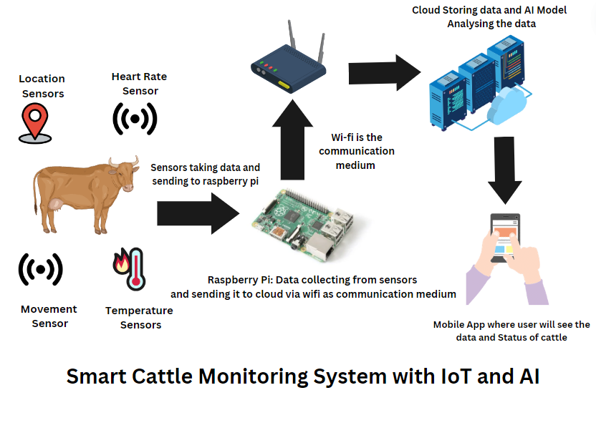

# **Feasibility Study:**

With the above-defined scope, the project is expected to be completed within the allocated time period. However, it is important to consider and address potential risks and resource requirements to ensure successful project execution and completion.

**Risks Involved:**

**1. Hardware Failures:**

**Risk:** Sensors, microcontrollers, or other hardware components may fail or malfunction.

**Reducing risk:** Select reliable components from reputable suppliers, maintain spare parts for quick replacements, and conduct thorough testing of hardware before deployment.

**2. Limited Budget:**

**Risk:** Project may exceed the budget constraints due to unforeseen expenses.

**Reducing risk:** Strict adherence to cost constraints, prioritize essential features, and use low-cost, commercially available hardware and open-source software solutions.

**3. Complexity of AI/ML Algorithm:**

**Risk:** Developing and integrating AI/ML algorithm may be more complex and time-consuming than anticipated.

**Reducing risk:** Use proven AI/ML frameworks (such as TensorFlow or PyTorch), start with simple models and incrementally improve them, and allocate sufficient time for algorithm development and testing.

**4. Resource Availability:**

**Risk:** Unavailability of required resources or delays in procurement.

**Reducing risk:** Plan and procure resources early in the project timeline, maintain a list of alternative suppliers, and keep buffer time for procurement in the project schedule.

**Resource Requirements:**

**1. Computing Resources:**

**Development Computers:** Laptops or desktops with sufficient processing power and memory for software development, AI/ML model training, and testing.

**Cloud Services:** Cloud platforms (such as AWS/Azure/Google) for data storage, processing and hosting the mobile applications.

**Development Tools:** Software development environments (Visual Studio Code, Python IDE), AI/ML development tools (TensorFlow or PyTorch).

**2. Hardware Components:**

**Sensors:** Health monitoring sensors (body temperature, heart rate, activity)

**Microcontrollers:** Raspberry Pi

**GPS Modules:** For location tracking.

**Communication Modules:** Wi-Fi modules for data transmission.

**Power Supplies:** Batteries or other power sources for hardware components.

**3. Software Tools:**

**Programming Languages:** C/C++ for microcontroller programming, Python for AI/ML algorithm and cloud integration.

**Development Frameworks:** TensorFlow or PyTorch for AI/ML development, and

Flutter(dart) mobile application development frameworks.

**4. Other Resources:**

**Farm Access:** Access to a cattle farm for field testing and deployment of the system.

**Testing Facilities:** Environment setup for initial testing and validation of hardware and software components

# **Solution Application Areas:**

* 1. **Is your project of some real value?**

Yes, the project has significant real-world value due to its potential to improve cattle health, increase farm productivity, and reduce operational costs.

* 1. **Industry or application domain:**

The primary target for the smart cattle monitoring system project is the agricultural and livestock industry. As of 2020, there were approximately 41.2 million buffaloes, 49.6 million cattle, 5.4 million donkeys, 78.2 million goats and 30.9 million sheep in Pakistan [2]

* 1. **How may that target domain benefit from your solution?**

The smart cattle monitoring system is designed to address the specific needs of cattle farmer/livestock owners by providing a cost-effective and efficient solution for managing the cattle. Smart cattle monitoring system offers a valuable solution for the agricultural and livestock industry, particularly in the cattle breeding and dairy production domain. By promoting animal health, reduced costs, and decision making by historical data

# **Tools/Technology:**

**Proposed Hardware Tools:**

**Sensors**: Temperature, heart rate, accelerometers.

**Microcontrollers**: Raspberry Pi

**GPS Modules**: For real-time location tracking

**Communication Modules**: Wi-Fi

**Power Supplies**: Battery packs, solar panels

**Enclosures**: Weather-resistant enclosures for hardware protection (Water proof)

**Proposed Software Tools:**

**Programming Languages**: C/C++ (microcontroller programming), Python (data processing, AI/ML)

**Development Environments**: Raspberry Pi IDE, PyCharm/VSCode

**AI/ML Frameworks**: TensorFlow or PyTorch

**Cloud Platforms**: AWS/Google Cloud Platform (GCP)/Microsoft Azure

**App Development**: Flutter (for mobile applications)

**Communication Protocols**: MQTT/ HTTP/HTTPS

1. **Responsibilities of the Team Members:**

Responsible, Accountable, Consulted, and Informed

|  |  |  |  |
| --- | --- | --- | --- |
| **Task Category** | **Supervisor** | **Zunair Shahid** | **Hina Roshan** |
| Project Requirements Gathering | C, I | R | C,I |
| Sensor Selection and Integration | C, I | R | R |
| Data Acquisition System Development | C, I | R | R |
| Cloud Platform Setup and Configuration | C, I | R | R |
| Data Security and Privacy Implementation | C, I | R | R |
| Mobile App Development (Urdu Interface, User Experience) | C, I | R | R |
| AI Model Development (Cattle Status Prediction) | C, I | R | R |
| Pilot Deployment Planning and Execution | C, I | R | C,I |
| Data Analysis and Interpretation | C, I | R | R |
| Reporting and Documentation | C, I | R | R |
| Project Presentations and Demos | C, I | R | R |

# **Milestones**

## First Evaluation:

In the First evaluation following things will be done:

* Hardware Development (IoT)
* Configuration of Cloud Platform
* Integration of Hardware with Cloud Platform.

## Second Evaluation:

During the second evaluation phase, all of the anticipated functions of the entire system, such as

* AI model development for cattle status prediction
* Mobile App Development (Urdu + English interface).
* Integration of AI models with cloud platform.
* Sensor installation on cattle at farms
* Initial data collection and system monitoring
* Initial data analysis on animal health, behavior, and alerts

# **14. Gantt Chart (Planning):**

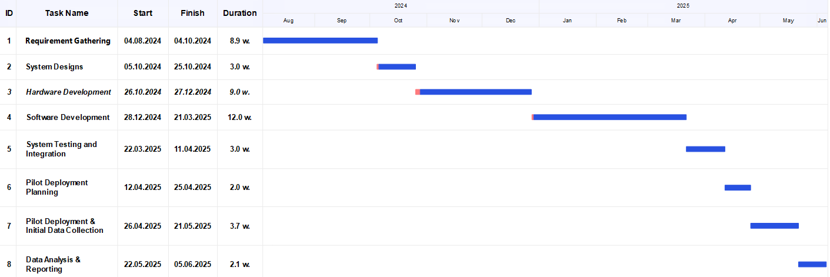

**15. References**

1. <https://livestock.punjab.gov.pk/livestock-contribution>
2. <https://en.wikipedia.org/wiki/Animal_husbandry_in_Pakistan>
3. Vigneswari, T. (2021). Smart IoT cloud-based livestock monitoring system: A survey. *Turkish Journal of Computer and Mathematics Education (TURCOMAT)*, *12*(10), 3308-3315.
4. Aswini, D., Santhya, S., Nandheni, T. S., & Sukirthini, N. (2017). Cattle health and environment monitoring system. *International Research Journal of Engineering and Technology*, *4*(3), 1899-1903.
5. Yusuf, S. H., & Bharani, A. (2021). A Study On Iot And Ai-Based Advanced Architecture For Livestock Management. *Webology (ISSN: 1735-188X)*, *18*(6).
6. JOUR,El Moutaouakil, Khalid,Noureddine, Falih,2023/11/01,857,864, A design of a smart farm system for cattle monitoring,32,10.11591/ijeecs.v32.i2.pp857-864,Indonesian Journal of Electrical Engineering and Computer Science
7. Darvesh, K., Khande, N., Avhad, S., & Khemchandani, M. (2023). IOT and AI based smart cattle health monitoring. *J Anim Sci*, *14*, 211-8.
8. Iwasaki, W., Morita, N., & Nagata, M. P. B. (2019). IoT sensors for smart livestock management. In *Chemical, gas, and biosensors for internet of things and related applications* (pp. 207-221). Elsevier.
9. Ilyas, Q. M., & Ahmad, M. (2020). Smart farming: An enhanced pursuit of sustainable remote livestock tracking and geo fencing using IoT and GPRS. *Wireless communications and mobile computing*, *2020*(1), 6660733.
10. Dutta, D., Natta, D., Mandal, S., & Ghosh, N. (2022). MOOnitor: An IoT based multi-sensory intelligent device for cattle activity monitoring. *Sensors and Actuators A: Physical*, *333*, 113271.